SERF Index Methodology

2026 Update Technical Note

by

Susan Randolph
Shaan Badenhorst
John Stewart
K. Anne Watson

Copyright 2026 by the Social and Economic Rights Fulfillment Index Project, serfindex.org

How to cite this Document

Randolph, Badenhorst, Stewart, and Watson, SERF Index Methodology
2026 Update Technical Note, Social and Economic Rights Fulfillment Index Project
2026, https://serfindex.uconn.edu/overview-2026/

How to cite the 2026 Update of the International SERF Index Data:

Randolph, Badenhorst, Stewart and Watson 2026 Update International SERF Index Data, Social and Economic Rights Fulfillment Index Project: https://serfindex.uconn.edu/2026-update-international-serf-index-data/

Copyright: Both this document and dataset are licensed under a Creative Commons Attribution-Non Commercial 4.0 International license. This means anyone may copy this document and/or use the dataset in whole or in part for non-commercial uses as long as they provide full attribution. However , those wishing to use the document and/or data set for commercial use must get permission from the lead author. Contact Susan.m.randolph@gmail.com.

2026 International SERF Index Update: Technical Note
Susan Randolph, Shaan Badenhorst, John Stewart, and K. Anne Watson

This technical note provides a detailed explanation of the methodology used to construct the 2026 Update of the International SERF Index. The basic SERF Index methodology was created through a three-year consultative process by Susan Randolph, Sakiko Fukuda-Parr and Terra Lawson-Remer. As with all measurement indices, the methodology has evolved to take account of emerging conceptual and data issues. The International SERF Index has been refined eight times since it was initially published in 2009. The 2026 Update of the International SERF Index extends the series by a year and now covers the 33 year period 1990 to 2023.
The book, Fulfilling Social and Economic Rights by Sakiko Fukuda-Parr, Terra Lawson-Remer and Susan Randolph (Oxford: Oxford University Press, 2015) provides a detailed account of the basic SERF Index methodology and insights gained from its application that is accessible to practitioners. The conceptual and methodological underpinnings of the SERF Index are also fully elaborated in two peer reviewed publications:
- Fukuda-Parr, Sakiko, Terra Lawson-Remer and Susan Randolph (2009) ‘An Index of Economic and Social Rights Fulfillment: Concept and Methodology.’ Journal of Human Rights. 8: 195-221. (https://www.tandfonline.com/doi/pdf/10.1080/14754830903110194 )
- Randolph, Susan, Sakiko Fukuda-Parr, Terra Lawson-Remer (2010) ‘Economic and Social Rights Fulfillment Index: Country Scores and Rankings.’ Journal of Human Rights, 9.3, 230-261. (https://www.tandfonline.com/doi/full/10.1080/14754835.2010.501257 )
The SERF Index measures a country’s economic and social rights achievement relative to what is feasible to achieve at the country’s per capita income level. That is, it looks at the actual enjoyment level of a right or right aspect relative to the possible level, as evidenced by the achievement of the best performing countries at each per capita income level. As such it measures how well a country is using its resources to ensure its people enjoy their economic and social rights. This year we also include the related performance measure introduced six years ago, the excess income metric. The excess income metric measures how efficiently a country ensures its people’s enjoyment of their economic and social rights by comparing the country’s actual income with the minimum income required to enable the observed rights enjoyment level.

1. Overview of the International SERF Index methodology
The International SERF Index measures the extent to which countries have met their immediate obligations of result on key substantive economic and social rights that are grounded in international law. The SERF Index uses objective, internationally comparable, publicly accessible statistical data published by national and international bodies. It gauges a country’s performance on each indicator relative to a benchmark reflecting what is feasible at the country’s current per capita income level. The International Covenant for Economic, Social, and Cultural Rights (ICESCR) articulates a list of essential substantive economic and social rights that the 173 nations (as of June 2026), representing a wide range of cultural traditions, who have ratified it concur are essential and that all people are entitled to, simply by virtue of being human. These are the rights to food, health, education, housing, work, and social security. The International SERF Index covers five out of six of these rights. We do not yet have sufficient internationally comparable data to independently include social security. However, the indicators used to measure the right to work also capture key elements of the right to social security; available data just do not enable a full separation between the right to work and the right to social security.
A fundamental principal of international law is that countries have a duty to progressively realise economic and social rights to the maximum of their available resources. Statistics like school enrolment and child mortality tell us only the extent to which individuals enjoy economic and social rights, but not whether a state is complying with its obligations to progressively fulfil human rights. Measuring economic and social rights fulfilment requires considering the perspectives of both the rights-holding individual and the duty-bearing government. While many widely available socio-economic indicators and other metrics, such as the Human Development Index (HDI) assess the level of rights enjoyment, they ignore the obligation level of the duty bearing state. The SERF Index methodology specifies obligations of progressive realisation using an innovative approach that maps an evidence based ‘achievement possibilities frontier’ (APF) to benchmark each country’s obligation at any given time. This methodology is the only ESR metrics methodology that:
- Considers the perspective of both the rights-holder and the duty-bearer measuring state compliance with obligations of progressive realisation;
- Makes possible objective assessment of whether the overall situation in a country is improving or deteriorating;
- Allows cross-country comparisons of rights fulfilment; and
- Provides a methodology to examine disparity in rights fulfilment between regions, or between racial and ethnic or other population sub-groups.

The International SERF Index and component Right Indices measure a country’s achievement relative to what it is feasible to achieve at the country’s per capita income level. That is, they look at the enjoyment level of a right relative to the best practice in countries with approximately the same per capita income. More specifically, the scores show the percentage of the feasible achievement obtained, at the country’s per capita income level. A low score means a country is not fulfilling the right or right aspect concerned to the extent possible at its per capita income level. A score of 100% on a right or right aspect does not mean everyone in the country enjoys the right or right aspect; it means the country is doing as well at ensuring the right as the historically best performing countries at that per capita income level. Thus, in the case of a very poor country, the score on the right or right aspect can be quite high even though the enjoyment level of the right or right aspect is quite limited. A country achieving a score of 100% cannot rest on its laurels. All countries are obligated to progressively fully realize the rights enumerated in the ICESCR. A score of 100% means the country is meeting its immediate obligation under Article 2.1 of the ICESCR to fulfil the right to the “maximum of its available resources” but unless all people are enjoying the right concerned, it is not meeting its longer-term obligation to “achieve the full realization” of the rights enumerated in the ICESCR. Some countries have more than enough income to ensure everyone enjoys a given right or right aspect but fail to do so. For these countries, a penalty is imposed on their scores. The penalty is larger the lower is the enjoyment level of the right. The penalty also increases the greater is the country’s income beyond that necessary to fully realize the right. As a result, in the case of a country with a high per capita income, the country’s score on a right aspect could be lower than the raw indicator value reflecting the enjoyment level of the right aspect.
Data constraints coupled with the different right challenges in high income countries versus other countries have led to our creation of two separate assessment standards:
- The “low and middle income” assessment standard holds countries to a basic level of rights fulfilment and is most relevant to low- and middle-income countries.
- The “high-income” assessment standard holds countries to a higher standard more relevant to the right challenges facing high-income countries.
Scores using both standards are calculated for all countries with the necessary data, enabling researchers to evaluate countries with the necessary data on either standard. The 2026 Update of the International SERF Index, component Right Indices and right aspect scores are comparable across time for each country, as well as between countries. When computing a country’s score on a right or right aspect, the most recently available data on a given right enjoyment indicator (and the per capita income data for the corresponding year) are used. However, because the surveys providing many of the indicators of rights enjoyment are not conducted annually, the data used for each year are not always unique. In line with recommendations from the European Commission’s Competence Centre on composite Indicators and Scoreboards (CC-COIN), where possible, we have used the modelled version of indicators provided by international organizations. In those few cases where modelled variants of the indicators are not available, we use a 10 year look-back period. For example, in the case of the right to work score for Burkina Faso, using the low- and middle- income assessment standard, the 2021-2023 series use data on the % not absolutely poor in 2021. If the most recently available data on an indicator is more than 10 years prior, the score for that right aspect is recorded as “missing”. The full 10-year look-back period is applied as needed to the data covering 2000 to 2023, but for the years 1990 to 1999, the look-back period never goes back further than 1990.
The construction of the 2026 Update of the International SERF Index is further elaborated below.

2. Benchmarking Country Obligations
The International Covenant of Economic, Social, and Cultural Rights (ICESCR) commits governments to fully realize the economic, social and cultural rights enumerated therein progressively. As stated in Article 2.1:
“Each State Party to the present Covenant undertakes to take steps, individually and through international assistance and co-operation, especially economic and technical, to the maximum of its available resources, with a view to achieving progressively the full realization of the rights recognized in the present Covenant, by all appropriate means including particularly the adoption of legislative measures.”

This ‘progressive realisation’ provision recognises that states have very different starting points in their ability to achieve full enjoyment of economic and social rights, as noted by Fukuda-Parr, et al. (2015)
“Countries around the world face hugely different levels of deprivation and capacity. Inherent in the idea of progressive realization is that a government’s ability to fulfil rights commitments depends on the level of resources (financial and other) available in the country.”

The enjoyment of the right to the highest attainable standard of health, for example, cannot be achieved overnight, as facilities need to be built, personnel trained, and policy incentives for businesses and households put in place and so on, for people to have access to healthcare. These arrangements require financial resources which may be beyond what governments and households can currently mobilise. Consequently, the performance of states with regard to progressively realising economic and social rights cannot be judged on the basis of outcomes – enjoyment of rights by people – alone. For example, the performance of the United States and Malawi cannot be compared based on their respective levels of child survival rates considering the hugely different levels of capacity in these two countries.
Thus, a country’s performance in fulfilling obligations for economic and social rights depends on:
- the actual economic and social rights (ESR) outcomes people enjoy, as indicated by socio-economic statistics that proxy for particular rights and right aspects; and
- a society’s capacity for fulfilment, as determined by the amount of economic resources available overall to the duty-bearing state.

The ‘progressive realisation’ provision has complicated and frustrated efforts to monitor countries’ fulfilment of their economic and social rights obligations, since, as Human Rights measurement scholar Chapman notes:
“It necessitates the development of a multiplicity of performance standards for each right in relationship to the varied… contexts of specific countries”.

That is, measures of ESR outcomes must reflect variable local specificities. The monitoring procedure adopted by the Committee on Economic, Social and Cultural Rights assesses performance relative to ‘benchmarks’. But this leaves the problem of setting the benchmark. In the absence of a conceptual and evidence-based model for setting benchmarks, States enjoy considerable discretion over where their benchmark is set, thus effectively leaving open an ‘escape hatch’ for States to avoid meeting their ESR obligations.
The SERF Index overcomes this problem. The innovation of the methodology lies in the construction of Achievement Possibilities Frontiers (APFs) that use an evidence-based approach to specify each country’s level of obligation for progressive realisation with regard to various aspects of each economic and social right. The basic construction of the SERF Index involves the following steps:
- Identify indicators that broadly summarise: i) the enjoyment level of the substantive rights articulated in international law and ii) country resource capacity.
- Specify country obligations with regard to each of the selected indicators and compute indicator scores reflecting the extent to which a country meets its obligations on each aspect of the right.
- For each substantive right, aggregate the indicator scores for the different right aspects into a component Right Index by averaging the indicator scores.
- Average the component Right Indices to get the SERF Index.
For most ESRs, resource constraints do not bind throughout the income range observed globally. Once resources no longer impose a constraint, countries are obligated to fully fulfil the substantive rights guaranteed under the ICESCR. The International SERF Index measures the extent to which countries are using their resources as effectively as possible to progressively fulfil their inhabitants’ substantive economic and social rights. In other words, we look at the extent to which the people in a country enjoy the substantive rights they are entitled to, taking into account how rich or poor the country is and therefore how well it ought to be able to ensure that food, housing etc. are accessible for its people.

Measuring economic and social rights enjoyment and state resources

Sources and definitions of rights and obligations
The SERF Index draws on international law – the Universal Declaration of Human Rights (UDHR), the International Covenant for Economic, Social and Cultural Rights (ICESCR) and numerous other international human rights legal instruments – to define the substantive rights of individuals and the obligations of states. The substance of these rights is detailed in General Comments of the Committee on Economic, Social, and Cultural Rights (CESCR).
The General Comments identify seven substantive economic and social rights; the
right to:
  - adequate food,
  - education,
  - highest attainable standards of physical and mental health,
  - adequate housing,
  - water and sanitation,
  - decent work, and
  - social security.

Following the Office of the High Commissioner for Human Rights 2012 guidelines on using indicators to monitor human rights, we collapse these into six rights, in view of the fact that access to water and sanitation are key components of the right to housing.
States bear the primary responsibility for the realisation of the rights of citizens and individuals residing within their borders. Their obligations are threefold: to respect, to protect, and to fulfil rights. These obligations also include the cross-cutting procedural rights of non-discrimination, participation, and accountability. General Comments 3, 9 and 20along with the Limburg Principlesand Maastricht Guidelines elaborate the nature and extent of the obligations accepted by State parties to the Covenant.
The SERF Index measures State parties’ compliance with their obligations for progressive realisation of economic and social rights, focusing on outcomes reflected in enjoyment of the substantive rights by people, adjusted for state capacity. It does not attempt to assess the extent to which States ensure the procedural rights of non-discrimination, participation, and accountability. The SERF Index complements other measurement tools such as those suggested by the Office of the High Commissioner for Human Rights. These and other initiatives, such as the Right to Education Index focus on different aspects of obligations, such as process (or policy efforts made by government), structure (institutionalised provisions), and outcomes (level of rights enjoyment in the population), while assessing performance on 50 to 100 aspects of each right. However, none attempts to provide a broad summary of performance and benchmark outcomes according to the obligation of progressive realization as does the SERF Index.

Selecting the indicators of rights enjoyment and resource capacity

A number of criteria govern the selection of the indicators. Beyond making sure selected indicators appropriately reflect enjoyment of the right concerned and resource capacity, selected indicators must be:
  - based on reliable data;
  - measured with objective methods;
  - legitimately comparable across countries and over time; and
  - publicly accessible.

To satisfy these criteria, all data sets used to construct the International SERF Index are international series that are maintained by international organisations. Further considerations for indicator selection include:
- data availability and country coverage;
- frequency of data collection;
- the extent of variation among countries;
- their ability to reflect the challenges most relevant to fulfilling a given right;
Additionally:
- indicators specifying the percentage of the population enjoying the right are prioritized over those indicating the average level of enjoyment of the right across the population;
- indicators of flow variables are preferred to indicators of stock variables; and
- preference is given to bellwether indicators sensitive to a variety of factors related to rights fulfilment.
In general, we have sought to keep the number of indicators reflecting different key aspects of a given right down to three.
Our selection of indicators is also practically constrained by current data availability. This, plus different rights challenges in high income countries versus most other countries led to our creation of two separate sets of scores using two different assessment standards: one standard relevant to the majority of countries, our “low- and middle-income” assessment standard, and the other most relevant to high income countries, our “high-income” assessment standard. For example, the high-income assessment standard includes a measure of affordable housing. Affordable housing is no less a concern for all other countries, it is just that there is no measure with broad coverage available currently for low-and middle-income countries. Regarding relevance, ensuring universal access to primary school is not an issue for high-income countries, so although this is an indicator we use in our low- and middle-income assessment standard, it is not included in our high-income assessment standard.
Data limitations currently preclude defining separate metrics for all six rights. The SERF Index includes separate scores for five rights—the rights to food, health, education, housing, and work—with key elements of the right to social security captured by the right to work and covers the years 1990 through 2023. Additionally, some of the series are not available for the full 1990-2023 period. For example, for the right to food using the high-income assessment standard, data are only available for 2015 through 2023. Available data do not enable us to fully separate the right to work from the right to social security at this time. The Right Indices and composite SERF Index are calculated using both assessment standards—“low- and middle-income” and “high-income”—for all countries with available data, enabling researchers to evaluate countries with the available data on either standard. Table 1 below shows the indicators currently used to measure enjoyment of key aspects of each right for each of the two assessment standards.
The 2026 Update incorporates the changes introduced in the 2023 through 2025 Updates. First, for the low- and middle-income assessment standard the total net primary school enrolment rate replaces the net primary enrolment rate given the longer and more comprehensive time series available. For the same reason, for both assessment standards the total net upper secondary school enrolment rate replaces the net secondary school enrolment rate. Additionally, for the low- and middle- income assessment standard the country’s harmonized test score has been added. This indicator reflects the general quality of schooling and is defined as the “Harmonized test scores from major international student achievement testing programs measured in TIMSS (Trends in International Maths and Science Study) equivalent units, where 300 is minimal attainment and 625 is advanced attainment”. Data on the absolute poverty rate are now available measured using 2021 PPP$ and accordingly our 2026 absolute poverty line is specified at $4.20 (2021 PPP$) per day. Further, for the high- income assessment standard we substitute the senior (age 60 to 80) survival rate for the adult (age 15 to 60) survival rate to better capture the health challenges facing high income countries. Finally, where possible, we compute scores disaggregated by sex. Specifically, the 2026 Update provides scores disaggregated by sex for both assessment standards in the case of all aspects of the right to education as well as the overall right to education itself, in the case of the right to food and in the case of the child and adult aspects of the right to health. Additionally, the 2026 Update also disaggregates data on long-term unemployment by sex.
Appendix Table A gives details of sources and definitions for each indicator. A detailed discussion of why particular indicators was selected is provided in Fukuda-Parr, Lawson-Remer, and Randolph (2015). As noted at the outset, States are required to fulfil economic and social rights progressively, and to commit the maximum of available resources to meet this obligation. As noted above, the SERF Index uses per capita GDP as the indicator of State resource capacity. While it might be argued that States with larger budgets or better institutions have a greater capacity to fulfil economic and social rights than those with the same per capita income but smaller budgets or poorer institutions, a State’s capacity depends on the choices it makes with regard to its taxing policies and institutional structure. Since the obligation to progressively realise economic and social rights requires States to collect and expend resources at the level necessary to meet their rights obligations, it is appropriate to measure resource capacity as reflected by the total resources available to the State, not the portion of those resources the State chooses to tap. The 2026 Update measures GDP per capita data in 2021 international purchasing power parity dollars (2021 PPP$) to standardise for inflation and purchasing power across countries and thus enable comparison over time and across countries. All Achievement Possibility Frontiers were updated as part of the 2025 Update using the most recent release of purchasing power parities (PPPs) data which are referenced to 2021 prices.
Table 1: Rights enjoyment indicators used to construct the 2026 update of the International SERF Index
 | Assessment Standard
Human Right/Indicator | Low- and Middle income | High-income | By sex
Right to food |  |  | √
% Children (under 5) not stunted | √ |  | √
% People food secure (based on the food insecurity experience scale, FIES) |  | √ | √ (adults 15 & over)
Right to education |  |  | √
Total net upper secondary school enrolment rate | √ | √ | √
Total net primary school enrolment rate | √ |  | √
% Students achieving level 3 or better on PISA test (by topic, Mathematics, Science & Reading) |  | √ | √
Average TIMSS equivalent harmonized test scores from major international student achievement testing programs | √ |  | √
Right to health
% Children (under 5) surviving to age 5 | √ | √ | √
% Adult (15-60) survival rate | √ |  | √
% Senior (60-80) survival rate |  | √ | √
% Couples (15-49) using modern contraceptives | √
% New-borns not low birth weight (<2500 grams) |  | √
Right to housing
% Population with at least “basic” sanitation | √
% Population with “basic” water on premises | √
% Population with “safely managed” sanitation |  | √
% Poorest quintile of population with access to affordable housing (total housing costs net of housing allowances is < 40% of disposable income net of housing allowances) |  | √
Right to work
% Population with income>$4.20 (2021 PPP$) per day | √
% Population with income > 50% median income |  | √
% Unemployed not long-term (>12 months) unemployed |  | √ | √

Calculating indicator scores by benchmarking a country’s obligations of progressive realisation
Achievement Possibility Frontiers (APFs) use an evidence-based approach to benchmark each country’s obligation with regard to each indicator reflecting the different aspects of each right. The APFs reflect what is feasible to achieve when a country allocates the maximum of available resources to fulfilling economic and social rights and uses those resources effectively and efficiently as is evidenced by the experience of the best performing countries at different per capita GDP levels. The frontiers are constructed so as to be stable over the medium term thus enabling inter-temporal comparison. Specifically, the APF for a given indicator is constructed by plotting the observed value of the indicator against per capita GDP (2021 PPP$) for each country over the past several decades. The frontier itself is defined as the outer envelope of the scatter plot, and the equation specifying the frontier is estimated by fitting a curve to the observations that define the outer envelope of the scatter. While earlier versions of the SERF Index measured GDP per capita in 2005 PPP$, as was the case for the 2012 through 2017 Updates of the International SERF Index, or 2011 PPP$, as was the case for the 2019 and 2020 Updates, or 2017 PPP$ as was the case for the 2021 through 2024 Updates, the 2025 Update of the International SERF Index re-estimated the frontiers using the more recently available 2021 PPP$ exchange rates. The 2021 PPP$ exchange rate series used the same core methodology as the 2017 ICP cycle, but further harmonized the computation process across regions. Appendix Table B shows the equations specifying the frontier for each indicator.
To better understand the process, consider the construction of the Right to Food Score using the low- and middle-income assessment standard. The first step, as discussed above, is to figure out the best statistical indicators to monitor. Some of the SERF Index’s metrics use multiple indicators, but only a single right enjoyment indicator is used in constructing the right to food score for the low- and middle-income assessment standard—a measure of child malnutrition prevalence. Specifically, as shown in Table 1, we use the percentage of children under 5 years of age who are not stunted, that is, whose height for age is not unusually low relative to the median (precisely, not more than 2 standard deviations below the median).These data come from the World Health Organization’s Global Database on Child Growth and Malnutrition. The stunting rate is a bellwether indicator of family malnutrition. It has been found to be more sensitive to both chronic caloric insufficiency and a diet chronically lacking in adequate protein and micronutrients and is less likely to be influenced by temporary illness than other measures of child under-nutrition. Also, because parents tend to protect the nutritional wellbeing of their children over their own, the child stunting rate also reflects the inability of parents to adequately ensure their own nutritional wellbeing. Because our focus is on rights enjoyment, we subtract the child stunting percentage from 100%. We then construct a scatter plot of the percentage of children under 5 who are not stunted against GDP per capita (2021PPP$) using all available country observations from 1990 to 2022.
For example, in Figure 1 below, each black dot is a single country observation for a particular year. The most recent observations available for India is highlighted. As can be seen there is a substantial spread between the best and worst performing countries at each per capita GDP level. We use econometric techniques to fit a curve to the outer boundary of the scatter plot (the solid red curve in Figure 1). This fitted curve is the Achievement Possibilities (APF). Based on country experience, it benchmarks for each per capita income level the percentage of children it is feasible to ensure are not stunted. The APF defines the level of a State’s immediate obligation to ensure the right for any given per capita GDP level (2021 PPP$).

Figure 1: Achievement Possibilities Frontier for “Percentage of children Not Stunted”
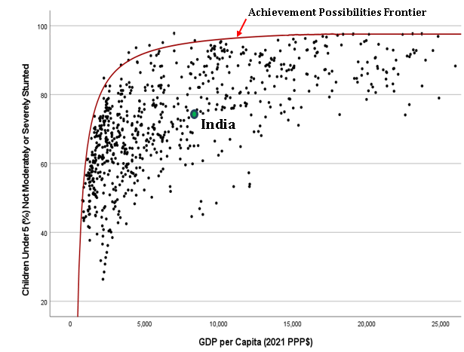

Assessing state performance: The rescaled indicator performance score
Ignoring, for the moment, some critical refinements, the approach to assessing State performance with regard to its immediate obligation is to compare the State’s actual performance to the feasible performance as benchmarked by the APF at the country’s current GDP per capita. So again, looking at Figure 1, India’s child stunting rate in 2023 was 32.8%, implying the percentage of children not stunted was 67.2%. However, at its then per capita GDP of $9,301 (2021 PPP$), it should have been possible as shown by the APF to ensure 95.7% of children under 5 were not stunted. Thus, our first cut at assessing India’s performance is to take the ratio of the observed percentage of children that are not stunted (67.2%) to the benchmark percentage of children not stunted (95.7%) and then multiply by 100 to yield the percentage of the feasible level achieved.
Two things should be noted about Figure 1 above. First, the observed percentage of children that are not stunted never reaches a value approaching zero. In fact, the lowest value observed is 26%, the percentage of children not stunted in Bangladesh in 1991. The observed minimum score differs widely across indicators. For example, the minimum observed score for the child survival rate (100% - % child mortality rate) is 66.9% (Niger males in 1990) and that for the percentage of the population with access to an improved water source on premises is 1% (Tanzania in 2000-2003). Given that we are comparing multiple indicators in the construction of the SERF Index, we need to standardise these indicators for two reasons. First, if we fail to do so our scores will not be comparable across rights, and indicators with a larger actual range will drive right scores comprised of more than one aspect. Second, we need to take into account the fact that even in the absence of any government efforts to ensure rights, certain indicators, such as the child survival rate, would have positive values while positive scores on other indicators, such as access to an improved water source on premises, or access to secondary schooling, substantially depend on public provision of goods and services and could be zero or close to zero.
We standardise the scores by computing the percentage of the feasible level achieved with reference to the minimum observed score on the indicator in the case of those indicators that do not substantially depend on public provision of goods and services. In Figure 2 below, the red horizontal line shows the minimum observed score of 26% on the child not stunted rate. So, for India, its achievement relative to this minimum observed score is 67.2% - 26% = 41.2% of children not stunted—the height of the blue arrow. Relative to the minimum, it is feasible for India to achieve 95.7% - 26% = 69.7% of children not stunted—the height of the red arrow. Thus, India’s performance score on the Right to Food is calculated as (41.2%/69.7%) x 100 = 59.1%.

Figure 2: Rescaling the indicator scores
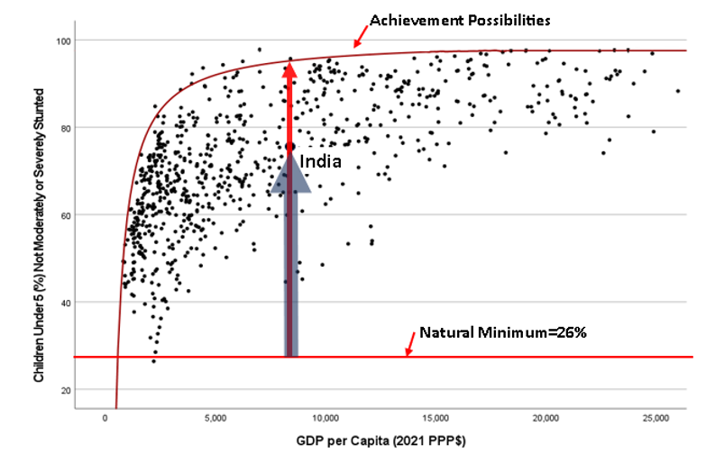

More generally, the rescaling formula is:
S = 100 [(actual value – minimum value) / (frontier value – minimum value)]
Here, formally we refer to S as the rescaled indicator performance score. The numerator of the ratio in brackets reflects the extent to which the State has ensured the given right aspect is enjoyed, while the denominator of the ratio reflects the level of the State’s immediate obligation to ensure that right aspect. After multiplying by 100, the rescaled indicator performance scores can be interpreted as the percentage of the immediate obligation met. The minimum values are set to approximate the indicator value one would expect to observe in a country with a subsistence per capita income level that places no priority on ensuring economic and social rights but does not systematically undermine them. This is approximated as zero for those indicators for which the score significantly depends on state provision of goods and services (e.g. the total net primary school enrollment rate); otherwise, as discussed above, it is approximated as the minimum value observed in any country in any year since 1990. The minimum scores for each indicator are shown in Appendix Table B.

Assessing state performance: the adjusted indicator performance score

There is one more issue that needs to be considered: some countries have many times the resources needed to ensure all people enjoy a given right but fail to ensure that all people do in fact enjoy that right. Figure 3 below fills out the scatter plot and APF for the percentage of children that are not stunted to include higher per capita income levels. Notice that the APF peaks and then becomes horizontal. The indicator value where the APF peaks (that we call Xp), is the highest value of the indicator observed at any income level. It is the current global best performance and, in most cases, implies the right aspect concerned is enjoyed by everyone in the country. In the case of the % of children that are not stunted, this occurs at 95%, since the height of 2.5% of children is expected to be more than 2 standard deviations below the median height for a well-nourished population. Appendix Table B specifies the (Xp) values for all the indicators. It should also be noted that in many cases, the frontier reaches a peak and then plateaus at a per capita GDP level well below the highest observed per capita income level.
We call the per capita income level where the frontier first reaches its peak Yp. It can be interpreted as the minimum per capita GDP required to ensure enjoyment of the right aspect concerned by everyone in the population given current knowledge of the structures and measures (legislation, policies, programs, etc.) that promote that goal. In the case of the percentage of children that are not stunted, this occurs at $16,000 (2021 PPP$) as seen in Figure 3 below.
In general, countries with income levels exceeding Yp have more than sufficient income to ensure everyone enjoys the aspect of the right concerned. The Yp values differ substantially across indicators and are also shown in Appendix Table B. The rate at which resources can be transformed into enjoyment of the right aspect concerned is shown by the shape of the frontier as it rises to its peak value and is implicit in the estimated frontier equations. Those rising more steeply imply greater ease in transforming income into enjoyment of the right aspect concerned.
The frontier value of the indicator will be the same for countries with per capita income levels above Yp whether their per capita income level is exactly Yp or two times Yp, or even 10 times Yp, and thus their rescaled indicator performance scores will be the same. However, it makes little sense to evaluate two countries with incomes above Yp and the same indicator score as performing equally well if one has twice as much income as the other. Looking again at Figure 3, notice that Egypt and Malaysia have nearly the identical percentage of children that are not stunted (79.6% for Egypt and 78.1% for Malaysia), yet Malaysia’s per capita income is nearly 2 times higher than Egypt’s ($32,078 vs. $16,360 measured in 2021 PPP$). Also notice that for per capita income levels higher than $16,000 (2021 PPP$)—the value of Yp for the percentage of children not stunted (which is somewhat less than Egypt’s per capita income)—the frontier reaches its peak value (95%), so resources no longer constrain countries’ ability to eliminate child stunting. For countries like Malaysia with per capita income levels multiple times what is needed to reach the frontier but who still fail to do so, we impose a penalty on their rescaled indicator performance score. In
Figure 3: Egypt’s and Malaysia’s resources exceed the level needed to eliminate
child stunting
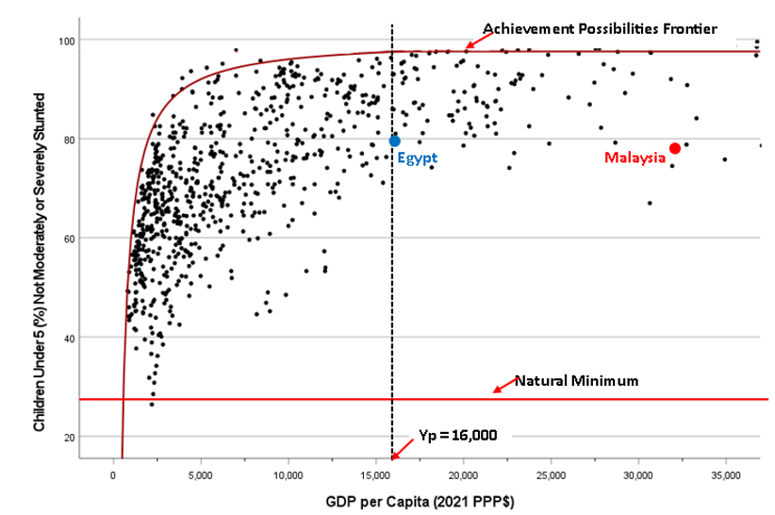
Malaysia’s case, based on the formula discussed below this is about 9 percentage points. A penalty is also imposed on Egypt’s rescaled indicator performance score, but the penalty is much smaller, about 0.2, since its per capita income is barely higher than Yp.
More generally, the final step in calculating the indicator performance score is to deduct a penalty from the rescaled indicator performance score when a country has income that is more than sufficient to ensure everyone in the country enjoys the right aspect concerned but fails to ensure that everyone does so. Thus, the final indicator performance score, what we formally call the adjusted indicator performance score, A, is:

A = S if Y <= Yp
A = S – penalty if Y >Yp
A related problem occurs when the estimated APFs asymptotically reach their peak. Consider Figure 4 below. The enlarged blue(on the left) and red (on the right) dots are the observations for two different countries. Both the indicator and frontier values for both countries are nearly identical, and both are failing to meet their obligations. However, the country represented by the red dot has two and a half times more resources than the country represented by the blue dot. As such, its score should be lower; a penalty should be imposed on its rescaled indicator score.

Figure 4: Example Achievement possibilities frontier (APF) with asymptotic peak
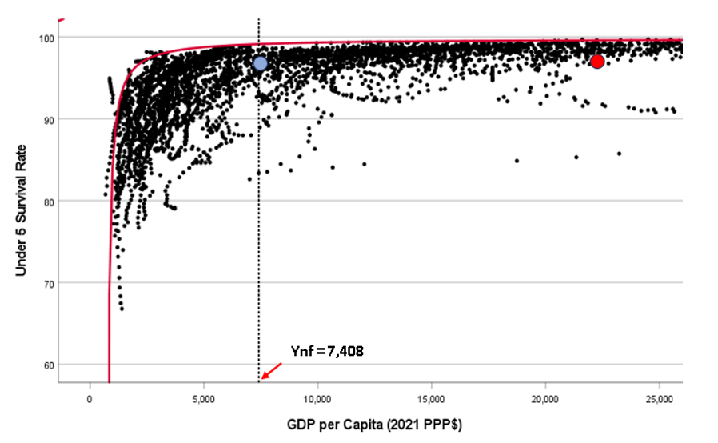
The question arises as to how flat the frontier needs to be before a penalty is imposed on the rescaled indicator scores of countries that fail to reach the frontier. We specify that level, call it the income at nearly flat, Ynf, as the point where the instantaneous slope of the frontier is .0001, that is when it has flattened to the point that it only increases by 1 percent per $10,000 increase in GDP per capita (2021 PPP$). Appendix B shows the per capita GDP level (2021 PPP$) where Yp or Ynf is reached and accordingly the income level where the penalty sets in. In the case of asymptotic APFs, the adjusted indicator performance score, A is:
A=S if Y <= Ynf
A=S – penalty if Y > Ynf

A number of alternative penalty formulas were considered in Fukuda-Parr, Lawson-Remer, and Randolph (2009) along with a set of axioms defining the characteristics one would like such a penalty formula to have. On the basis of the axioms, penalty formula F was identified as meeting all but the flexibility criterion. A refinement of penalty formula F offered in Randolph, Fukuda-Parr, Lawson-Remer (2010) ensures it meets the flexibility criterion as well. The resultant adjusted indicator performance score, A, when Y>Yp is:
A $=100[{\left(\frac{S}{100}\right)}^{{\left(\frac{Y}{Yp}\right)}^{β}}]$
In the case of APFs with asymptotic peaks we substitute the per capita income level when the slope of the frontier flattens to .0001, Ynf, for Yp in the formula above.
The value of β determines the severity of the penalty and for purposes of calculating the SERF indicator scores, β is set equal to 0.5. Figure 5 plots the adjusted indicator performance score against the ratio of a country’s per capita GDP to the Yp value for rescaled indicator performance scores, S scores, of 95%, 90%, 80%, 60%, and 40%. For example, the figure indicates that if a country has an S score of 95%, the penalty reduces the adjusted indicator performance score to 85% as its income rises to ten times the minimum amount necessary to fulfil the right aspect concerned.

Figure 5: Penalty for different Y/Yp values
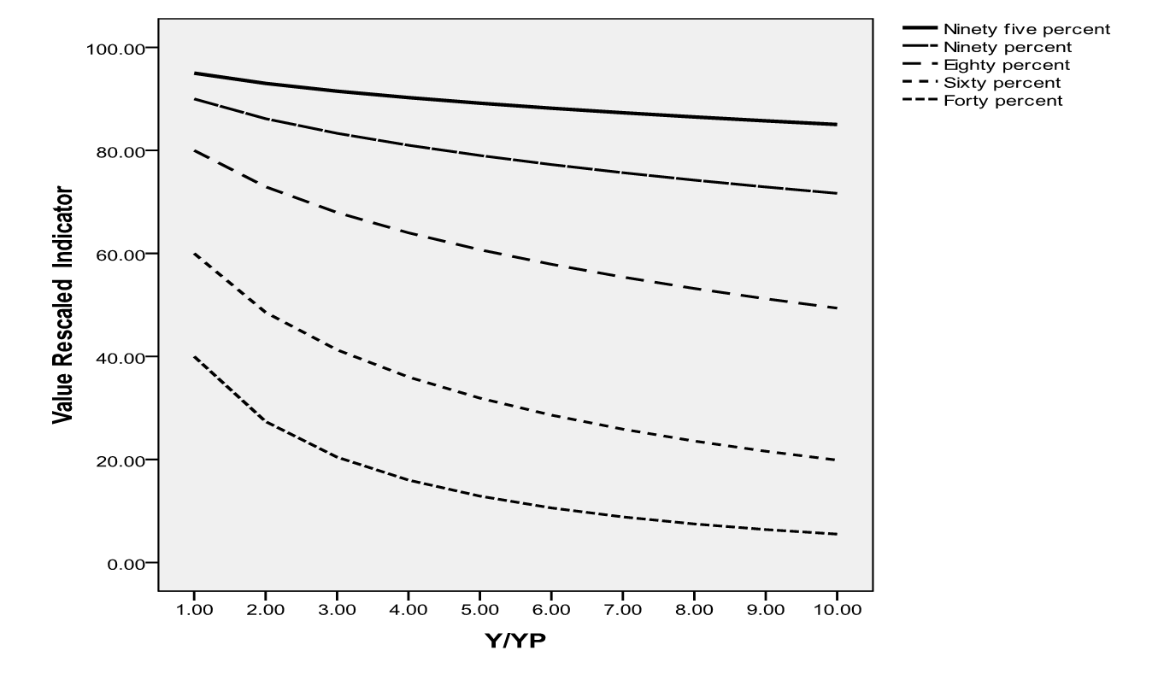

Component Right Indices & the International SERF Index
Country scores on the Component Right Indices are computed as the simple average of the underlying adjusted indicator performance scores for the different aspects of the right assessed. For simplicity sake, we will refer to the adjusted indicator performance scores simply as the indicator scores from here on out. So for example, using the low- and middle-income assessment standard, a country’s score on the Right to Education Index is the average of the indicator scores for the total net primary school enrollment rate, the total net secondary school enrollment rate, and the TIMSS equivalent harmonized test scores. In the event a single bellwether indicator is used to assess the enjoyment of a right, the country’s score on the Right Index concerned is simply the relevant indicator score. So for example, using the low- and middle-income assessment standard, a country’s score on the Right to Food Index is the indicator score for the percentage of children that are not stunted. Thus, differentiating between the different indicator scores, A, with i, and denoting n as the number of indicator scores relevant to right k, the formula for a country’s score on a given substantive Right Index, R_{k}, is:
R_{k} = ΣA_{i}/n
The exception is for the high-income right to education score. Here the three education quality indicator scores (percent of students achieving level 3 or better on the PISA math, PISA science and PISA reading scores) are first averaged and then that result is averaged with the education access score (the total net secondary school enrollment rate).

Finally, the country’s scores on the substantive Right Indices are averaged to yield the International SERF Index score. That is, given that we have 5 substantive rights, R,:
SERF Index = ΣR_{k} /5
Table 2 below shows the indicator scores for the 2026 Update of the International SERF Index that are averaged for each right for both assessment standards.

Table 2. Sub-scores Comprising Scores on Right Indices by Assessment Standard
 | Assessment Standard
Right and Sub-Rights | Low- and Middle- Income | High-Income
Right to food score
Children non-stunted score | √
Food security score |  | √
Right to education score
Secondary school enrollment score | √ | √
Primary school enrollment score | √
Harmonized education quality score | √
PISA education quality score (average math, science & reading scores) |  | √
Right to health score
Children surviving to age 5 score | √ | √
Adult (15-60) survival score | √
Senior (60-80) survival score |  | √
Modern contraceptive use score | √
Birthweight score |  | √
Right to housing score
Basic sanitation score | √
Water on premises score | √
Safely managed sanitation score |  | √
Affordable housing score |  | √
Right to work score
Absolute poverty score | √
Relative poverty score |  | √
Long term unemployment score |  | √

6. Excess Income Measure
In the 2020 Update, we introduced a new related performance measure, the Excess Income score, that measures a country’s efficiency by comparing the country’s actual income with the minimum income required to enable the observed enjoyment level. The ‘Excess Income’ measure of performance reflects how efficiently a country is using its resources to attain its current level of rights enjoyment. Consider Country A indicated by the large red circle in Figure 6 below showing the percent of children under 5 that are not stunted. Country A has 86.4% of its children who are not stunted and a GDP per capita of $20,200 (2021 PPP$). Moving from Country A horizontally to the left, we see the % of children not stunted value of 86.4% intersects the frontier at a GDP/capita of $2,400 (2021 PPP$). This is a measure of the minimum necessary GDP per capita to reach Country A’s performance level. Country A has 20,200/ 2,400 = 8.42 times the necessary income to do as well as it is. This is its Excess Income score. The Excess Income scores are calculated for each right aspect.
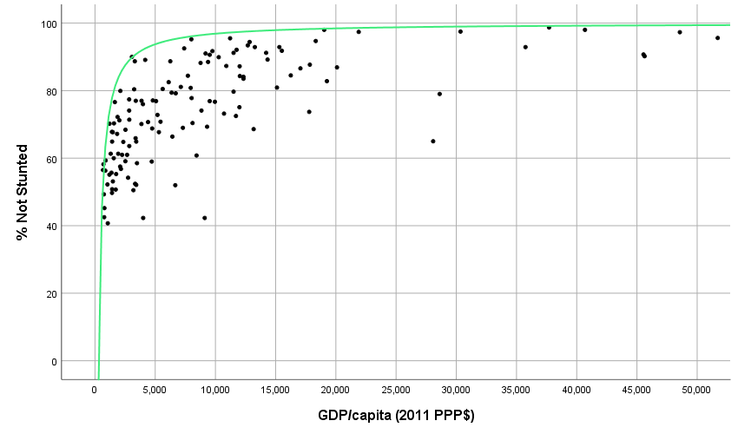
Figure 6: Excess Income Score
GDP per capita (2021 PPP$)

7. References
Chapman, Audrey. (2007) The Status of Efforts to Monitor Economic, Social, and Cultural Rights. Chapter 7, pp. 143-164 in Shareen Hertel and Lanse Minkler (eds.), Economic Rights: Conceptual, Measurement and Policy Issues. Cambridge: Cambridge University Press.
Chapman, Audrey. (1996) “A Violations Approach for Monitoring the International Covenant on Economic, Social, and Cultural Rights,” Human Rights Quarterly, 18(1), 23-66.
(Economic and Social Council), Committee on Economic Social and Cultural Rights. (1990) “General Comment 3: The Nature of States Parties’ Obligations”, Fifth Session, December 14.
(Economic and Social Council), Committee on Economic Social and Cultural Rights. (1991) “General Comment 4: The Right to Adequate Housing”, Sixth Session, 13 December.
(Economic and Social Council), Committee on Economic Social and Cultural Rights. (1997) “General Comment 7: The Right to Adequate Housing—Forced Evictions”, Sixteenth session, 20 May.
(Economic and Social Council), Committee on Economic Social and Cultural Rights. (1998) “General Comment 9: The Domestic Application of the Covenant” Nineteenth session, 16 November – 4 December, Doc. E/C.12/1998/24, 3 December 1998.
(Economic and Social Council), Committee on Economic Social and Cultural Rights. (1999a) “General Comment 11: Plans of Action for Primary Education”, Twentieth session, Geneva, 26 April – 14 May 1999, Document E/C.12/1999/4.
(Economic and Social Council), Committee on Economic Social and Cultural Rights. (1999b) “General Comment 12: The right to adequate food”, Twentieth Session of the Economic and Social Council, Geneva, 26 April – 14 May. Document E/C.12/1999/5.
(Economic and Social Council), Committee on Economic Social and Cultural Rights. (1999c) “General Comment 13: The Right to Education” Twenty-first session 15 November – 3 December 1999. Document E/C.12/1999/10.
(Economic and Social Council), Committee on Economic, Social and Cultural Rights. (2000) “General Comment 14: The Right to the Highest Attainable Standard of Health”, 22nd Session, 25 April – 12 May 2000. Document E/C.12/2000/4.
(Economic and Social Council), Committee on Economic, Social and Cultural Rights. (2005b) “General Comment No. 18: The Right to Work”, 35th Session, 7-25 November 2005. Document E/C.12/GC/18, 6 February 2006.
(Economic and Social Council), Committee on Economic, Social and Cultural Rights. (2007) “General Comment No. 19: The Right to Social Security” 39th session, 5-23 November. Document E/C.12/GC/19, 4 February 2008.

(Economic and Social Council) Committee on Economic, Social and Cultural Rights (2009) ‘General Comment No. 20: Non-discrimination in economic, social and cultural rights’, 42nd session, May 4-22, Document E/C.12GC/20, 2 July 2009.

(Economic and Social Council), Committee on Economic, Social and Cultural Rights. (2016a ) General Comment No. 22 (2016) on the right to sexual and reproductive health’ E/C.12/GC/22.2, 2 May 2016.

(Economic and Social Council), Committee on Economic, Social and Cultural Rights. (2016b) ‘General Comment No. 23 (2016) on the right to just and favourable conditions of work’, E/C.12/GC/23, 27 April 2016
Fukuda-Parr, Sakiko, Terra Lawson-Remer and Susan Randolph. (2009) “An Index of Economic and Social Rights Fulfillment: Concept and Methodology”, Journal of Human Rights, 8: 195-221.
Fukuda-Parr, Sakiko, Terra Lawson-Remer and Susan Randolph, Fulfilling Social and Economic Rights (Oxford: Oxford University Press, 2015)
Randolph, Susan, Sakiko Fukuda-Parr, and Terra Lawson-Remer. (2010). “Economic and Social Rights Fulfillment Index: Country Scores and Rankings”, Journal of Human Rights. 9: 230-261, 2010.
United Nations. (1945) Charter of the United Nations (San Francisco, 26 June 1945) (entered into force 24 Oct. 1945).
United Nations. (1948) Universal Declaration of Human Rights (UDHR), adopted 10 Dec. 1948, United Nations General Assembly Res. 217 A (III) (1948) New York.
United Nations. (1966) International Covenant on Economic, Social and Cultural Rights (ICESCR), 1966. Adopted 16 Dec. 1966, General Assembly Res. 2200 (XXI), U.N. GAOR, 21st Sess., Supp. No. 16, U.N. Doc. A/6316 (1966), 993 U.N.T.S. 3 (entered into force 3 Jan. 1976).
United Nations. (1987) The Limburg Principles on the Implementation of the International Covenant on Economic, Social and Cultural Rights. Guidelines adopted at a workshop sponsored by the International Commission of Jurists, the Faculty of Law of the University of Limburg, and the Urban Morgan Institute for Human Rights, University of Cincinnati, Maastricht, Netherlands, 22-26 January 1997, UN doc. E/CN.4/1987/17.
United Nations (2000) The Maastricht Guidelines on Violations of Economic, Social and Cultural Rights. Guidelines adopted at a workshop sponsored by the International Commission of Jurists, the Urban Morgan Institute for Human Rights and the Center for Human Rights of the Faculty of Law of Maastricht University, Maastricht, Netherlands, 22-26 January, 1997. UN doc. E/C.12/2000/13.
United Nations Office of the High Commissioner for Human Rights (2012).Human Rights Indicators: A Guide to Measurement and Implementation. HR/PUB/12/5.New York: Office of the High Commissioner for Human Rights, United Nations.

Appendix Table A: Indicator Definitions and Data Sources .

Indicator | Assessment Standard | Primary Source | Date Accessed | Definition
Resources
GDP per capita (2021 PPP$) | Both | World Bank International Comparison Project. | January 22, 2026 from WB WDI at https://databank.worldbank.org/data/source/world-development-indicators# | GDP per capita based on purchasing power parity (PPP), PPP GDP is gross domestic product converted to international dollars using purchasing power parity rates. An international dollar has the same purchasing power over GDP as the U.S. dollar has in the United States. GDP at purchaser’s prices is the sum of gross value added by all resident producers in the economy plus any product taxes and minus any subsidies not included in the value of the products. It is calculated without making deductions for depreciation of fabricated assets or for depletion and degradation of natural resources. Data are in constant 2021 international dollars.
Education
Total Upper Secondary Net Enrolment Rate | Both & By Sex | United Nations Educational, Scientific, and Cultural Organization (UNESCO) Institute for Statistics (UIS). | January 22, 2026 from UIS Statistics database http://data.uis.unesco.org/ | Total net enrolment rate: Total number of students in the official school age range for the given level of education who are enrolled in any level of education expressed as percentage of the population of the same age group for the given level of education. The total net enrolment rate should be based on total enrolment of the official relevant school age group in any level of education for all types of schools and education institutions, including public, private and all other institutions that provide organized educational programmes. Note: data source(s) used School register or school census for data on enrolment by age. UNPD population estimates for school-age population.  .
Total Net Primary Enrolment Rate | Low-and Middle- Income & by Sex | United Nations Educational, Scientific, and Cultural Organization (UNESCO) Institute for Statistics (UIS). | January 22, 2026 from UIS Statistics database http://data.uis.unesco.org/ | Total net enrolment rate:. Total number of students in the official school age range for the given level of education who are enrolled in any level of education expressed as percentage of the population of the same age group for the given level of education. The total net enrolment rate should be based on total enrolment of the official relevant school age group in any level of education for all types of schools and education institutions, including public, private and all other institutions that provide organized educational programmes. Note: data source(s) used School register or school census for data on enrolment by age. UNPD population estimates for school-age population.
Harmonized Test Scores | Low- and Middle- Income & by Sex | World Bank and Patrinos and Angrist (2018) http://documents.worldbank.org/curated/en/390321538076747773/Global-Dataset-on-Education-Quality-A-Review-and-Update-2000-2017. | January 22, 2026 from https://databank.worldbank.org/source/human-capital-index | Harmonized test scores from major international student achievement testing programs. The test scores are measured in TIMMS-equivalent units, where 300 is minimal attainment and 625 is advanced attainment. Most recent estimates are used. Year of most recent estimate shown in data notes. Test scores from the following testing programs are included: • TIMSS/PIRLS: Refers to average of test scores from TIMSS (Trends in International Maths and Science Study) and PIRLS (Progress in International Reading Literacy Study), both carried out by the International Association for the Evaluation of Educational Achievement. Data from each PIRLS round is moved to the year of the nearest TIMSS round and averaged with the TIMSS data. • PISA: Refers to test scores from Programme for International Student Assessment • PISA+TIMSS/PIRLS: Refers to the average of these programs for countries and years where both are available • SACMEQ: Refers to test scores from Southern and Eastern Africa Consortium for Monitoring Educational Quality • PASEC: Refers to test scores from Program of Analysis of Education Systems • LLECE: Refers to test scores from Latin American Laboratory for Assessment of the Quality of Education • PILNA: Refers to test scores from Pacific Islands Literacy and Numeracy Assessment • EGRA: Refers to test scores from nationally-representative Early Grade Reading Assessments • EGRANR: Refers to test scores from non-nationally-representative Early Grade Reading Assessments
^ % Scoring Level 3 or greater on PISA science test | High-Income & by Sex | Program for International Student Assessment (PISA) | January 12, 2025 from WB Edstats https://databank.worldbank.org/source/education-statistics | Achievement levels run from 1 to 6. At Level 3, students can draw upon moderately complex content knowledge to identify or construct explanations of familiar phenomena. In less familiar or more complex situations, they can construct explanations with relevant cueing or support. They can draw on elements of procedural or epistemic knowledge to carry out a simple experiment in a constrained context. Level 3 students are able to distinguish between scientific and non-scientific issues and identify the evidence supporting a scientific claim. Level definition from figure 4.10 in OECD (2018), “PISA for Development Reading Framework”, in PISA for Development Assessment and Analytical Framework: Reading, Mathematics, and Science, OECD publishing, Paris, https://doi.org/10.1787/9789264305274-4-en
^ % Scoring Level 3 or greater on PISA mathematics test | High-Income & By Sex | Program for International Student Assessment (PISA) | January 12, 2025 from WB Edstats https://databank.worldbank.org/source/education-statistics | Achievement levels run from 1 to 6. At Level 3, students can execute clearly described procedures, including those that require sequential decisions. Their interpretations are sufficiently sound to be a base for building a simple model or for selecting and applying simple problem-solving strategies. Students at this level can interpret and use representations based on different information sources and reason directly from them. They typically show some ability to handle percentages, fractions and decimal numbers, and to work with proportional relationships. Their solutions reflect that they have engaged in basic interpretation and reasoning. Level definition from figure 3.3 in OECD (2018), “PISA for Development Reading Framework”, in PISA for Development Assessment and Analytical Framework: Reading, Mathematics, and Science, OECD publishing, Paris, https://doi.org/10.1787/9789264305274-4-en
^ % Scoring Level 3 or greater on PISA Reading Test | High-Income & By Sex | Program for International Student Assessment | January 12, 2025 from WB Edstats https://databank.worldbank.org/source/education-statistics | Achievement levels run from 1 to 6. Tasks at this level (level 3) require the reader to locate, and in some cases recognise the relationship between several pieces of information that must meet multiple conditions. Interpretative tasks at this level require the reader to integrate several parts of a text in order to identify a main idea, understand a relationship, or construe the meaning of a word or phrase. They need to take into account many features in comparing, contrasting, or categorizing. Often the required information is not prominent or there is much competing information; or there are other text obstacles, such as ideas that are contrary to expectation or are negatively worded. Reflective tasks at this level may require connections, comparisons, and explanations, or they may require the reader to evaluate a feature of the text. Some reflective tasks require readers to demonstrate a fine understanding of the text in relation to familiar, everyday knowledge. Other tasks do not require detailed text comprehension but require the reader to draw on less common knowledge. Level definition from figure 2.2 in OECD (2018), “PISA for Development Reading Framework”, in PISA for Development Assessment and Analytical Framework: Reading, Mathematics, and Science, OECD publishing, Paris, https://doi.org/10.1787/9789264305274-4-en
Food
100% - Malnutrition Prevalence - height for Age (% children under 5) | Low-and Middle- Income & By Sex | UNICEF, WHO, World Bank: Joint child malnutrition estimates (JME) | January 22, 2026 from WB WDI  https://databank.worldbank.org/data/reports.aspx?source=world-development-indicators | 100 – prevalence of stunting. Prevalence of stunting is the percentage of children under age 5 whose height for age is more than two standard deviations below the median for the international reference population ages 0-59 months. For children up to two-years-old height is measured by recumbent length. For older children height is measured by stature while standing. The data are based on the WHO’s new child growth standards released in 2006. UNICEF, WHO, World Bank: Joint child malnutrition estimates (JME). Aggregation is based on UNICEF, WHO, and the World Bank harmonised dataset (adjusted, comparable data) and methodology. Modeled data based on surveys given priority over raw survey data estimates.
100% - % Moderately or Severely Food Insecure | High-Income (% population) & by sex (adults 15 and over) | Food and Agricultural Organization (FAO) | January 22,2026 from unstats SDG database https://unstats.un.org/sdgs/dataportal/database | 100 – proportion of population living in moderately or severely food insecure households. The indicator measures the percentage of individuals in the population who live in households experiencing food insecurity at moderate or severe levels during the reference period. The severity of food insecurity, defined as a latent trait, is measured on the Food Insecurity Experience Scale global reference scale, a measurement standard established by FAO through the application of the Food Insecurity Experience Scale
Health
Senior (60-80) survival  rate (% cohort) | High-Income & by Sex | United Nations Population Division (UNPD) | January 22, 2026 both sexes and by sex  UN Population Division(UNPD) database  https://population.un.org/wpp/downloads?folder=Standard%20Projections&group=Mortality | Extracted from life tables: Number of survivors by age for a hypothetical cohort of 100,000 newborns who would be subject during all their lives to the mortality rates of a given year. Data are presented in thousands." The senior survival rate is = 100* (number living to 80) / (number living to 60.
Adult (15-60) survival rate (% cohort) | Low- and Middle- Income & by Sex | United Nations Population Division (UNPD). | January 22, 2026 for both sexes, and by sex from UN Population Division (UNPD) database  https://population.un.org/wpp/downloads?folder=Standard%20Projections&group=Mortality | (1000 – Adult Mortality Rate )/ 10 where Adult mortality rate, is the probability per 1000 of dying between the ages of 15 and 60--that is, the probability of a 15-year-old dying before reaching age 60, if subject to age-specific mortality rates of the specified year between those ages.
100% - child (under 5) mortality rate/10 | Both & by Sex | UN Inter-agency Group for Child Mortality Estimation (UNICEF, WHO, World Bank, UN DESA Population Division).  Secondary source United Nations Population Division | January 22, 2026 for both sexes and by sex from WB WDI https://databank.worldbank.org/data/source/world-development-indicators#  Secondary January 22, 2026  For both sexes and by sex https://population.un.org/wpp/Download/Standard/Mortality/ | (1000 – under-five mortality rate)/10 where the under-five mortality rate is the probability per 1,000 that a newborn baby will die before reaching age five, if subject to age-specific mortality rates of the specified year.
#Modern contraceptive Use rate (% couples 15-49) (Modeled) | Low- and Middle- Income | Compiled by United Nations Population Division from household surveys, including Demographic and Health Surveys, and Multiple Indicator Cluster Surveys. | January 22, 2026 from UN population division (UNPD) database https://population.un.org/dataportal | Modern contraceptive prevalence rate is the percentage of women who are practising, or whose sexual partners are practising, at least one modern method of contraception. It is usually measured for women ages 15-49 who are married or in union. Modern methods of contraception include female and male sterilization, oral hormonal pills, the intra-uterine device (IUD), the male condom, injectables, the implant (including Norplant), vaginal barrier methods, the female condom and emergency contraception.
100% - % Low Birth Weight Babies | High-Income | Primary source OECD statistics,  Secondary source WB_WDI. | January 23, 2026 from OECD https://data-explorer.oecd.org/.  Secondary  January 22, 2026 from WB_WDI  https://databank.worldbank.org/data/source/world-development-indicators# | 100 - % low birth weight newborns. Number of live births weighing less than 2500 grams as a percentage of total number of live births. (Data values restricted to upper middle and high-income countries.)
Housing
% population with basic access to water on premises | Low-and Middle- Income | WHO UNICEF Joint Monitoring Project (JMP) | January 23, 2026 from JMP data https://washdata.org/data/household | Improved drinking water sources are those which, by nature of their design and construction, have the potential to deliver safe water. The JMP subdivides the population using improved sources into three groups according to the level of service provided. In order to meet the criteria for a safely managed drinking water service, people must use an improved source meeting three criteria: a) it should be accessible on premises, b) water should be available when needed, and c) the water supplied should be free from contamination. If the improved source does not meet any one of these criteria but a round trip to collect water takes 30 minutes or less, then it will be classified as a basic drinking water service.
% population with at least basic sanitation. | Low- and Middle-Income | WHO UNICEF Joint Monitoring Project (JMP) | January 22, 2026 from WB_WDI https://databank.worldbank.org/data/source/world-development-indicators# | Basic sanitation is defined as use of improved facilities that are not shared with other households. Improved sanitation facilities are those designed to hygienically separate excreta from human contact.
% households with safely managed sanitation | High-Income | WHO UNICEF Joint Monitoring Project (JMP) | January 22, 2026 from WB_WDI https://databank.worldbank.org/data/source/world-development-indicators# | Safely managed sanitation is defined as use of improved facilities that are not shared with other households and where excreta are safely disposed in situ or transported and treated off-site. Improved sanitation facilities are those designed to hygienically separate excreta from human contact.
% poorest population quintile with affordable housing | High-Income | Eurostats | January 23, 2026 from Eurostats at https://ec.europa.eu/eurostat/databrowser/view/ILC_LVHO07B_custom_477428/default/table?lang=en | 100 – the housing cost overburden rate among the poorest population quintile. The housing cost overburden rate is the percentage of the population living in households where the total housing cost (‘net’ of housing allowances) represents more than 40% of disposable income (‘net’ of housing allowances). Costs include rent or mortgage (principal and interest) costs as well as the costs of mandatory services and charges, regular maintenance and repair, taxes and utilities.
Right to Work
100% - % Relative Poverty Rate | High-Income | Primary source Luxembourg Income Study,  Secondary source OECD | January 22, 2026 from Luxembourg Income Study Key Figures https://www.lisdatacenter.org/data-access/key-figures/ J  January 23, 2026 from OECD https://data-explorer.oecd.org/ | Relative poverty rate defined with reference to 50% of median income. Primary source Luxembourg Income Study (LIS), Secondary source OECD. LIS definition: Indicator of poverty status of the household to which the individual belongs to, based on the equivalised disposable household income concept and with respect to the 50% of the median. OECD definition: The poverty rate is the ratio of the number of people whose income falls below the poverty line; taken as half the median household income of the total population.
# 100% - Poverty Headcount ratio (at $4.20 2021 PPP$ per day) | Low-and Middle- Income | World Bank Poverty and Inequality Platform | January 22, 2026 from  WB_ WDI https://databank.worldbank.org/data/source/world-development-indicators# | 100 – the poverty headcount ratio at $4.20 (2021 PPP). Poverty headcount ratio at $4.20 a day is the percentage of the population living on less than $4.20 a day at 2021 international prices. As a result of revisions in PPP exchange rates, poverty rates for individual countries cannot be compared with poverty rates reported in earlier editions. Data from World Bank, Development Research Group are based on primary household survey data obtained from government statistical agencies and World Bank country departments. Data for high-income economies are from the Luxembourg Income Study database. For more information and methodology, please see http://pip.worldbank.org.
100% - % Long-term Unemployed (%unemployed) | High-Income | OECD | January 23, 2026 primary for both sexes and by sex from OECD https://dataexplorer.oecd.org | Long-term unemployment refers to the number of people with continuous periods of unemployment extending for 12 months or longer, expressed as a percentage of the total unemployed.
# indicates new indicator and frontier estimate for 2026 update
^The data by sex were corrected to ensure the percentage achieving each score was the percentage of that sex not the percentage of all students taking the test.

Appendix Table B: Frontier Equations, Peak Indicator Values, Income level at Peak Indicator Value, Minimum Value*

Indicator | Equation | Yp  Global Best Max | X at Yp  GDP at indicator max | Ynf  Indicator Value at nearly flat | X at Ynf  GDP at indicator nearly flat | X at Ymin  GDP at indicator Minimum | Indicator  Minimum Value
Resources
GDP per capita (2021 PPP$)
Health
Senior Survival sexes combined | Y = 80 – 300,000/(x+6,200) | 80 | asymptotic | 74.5 | 48,572 | -1,200 | Lesotho 2007 20
Male Senior Survival | Y = 77 – 400,000/(x+8,000) | 77 | asymptotic | 70.7 | 55,246 | -1,846 | Bolivia 2021 12.3% 12
Female Senior Survival | Y = 86-215,000/(x+4,200) | 86 | asymptotic | 81.4 | 42,168 | -942 | South Sudan 1990 20
Adult Survival sexes combined | Y = 95.5 – 20,000/(x-300) | 95.5 | asymptotic | 94.1 | 14,442 | 596 | South Sudan 1990 28
Male Adult Survival | Y = 95.3 – 35,000/(x+200) | 95.3 | asymptotic | 93.4 | 18,508 | 291 | Lesotho 2007 23.6%24
Female Adult Survival | Y = 97.5 – 22,000/(x-500) | 97.5 | asymptotic | 96.0 | 15,332 | 831 | Zimbabwe 2001 31.3% 31
Child Survival sexes combined | Y = 99.8 – 4,500/ (x – 700) | 99.8 | asymptotic | 99.1 | 7,408 | 846 | Niger 1990 males 69
Male child survival | Y = 99.9– 6,000/(x-550) | 99.9 | asymptotic | 99.1 | 8,296 | 773 | Sierra Leone 1990 72.8% 73
Female child survival | Y = 99.9 –4,400/(x-700) | 99.9 | asymptotic | 99.2 | 7,333 | 877 | Sierra Leone 1990 75
Modern Contraceptive Use | Y = 81.5– 30,000/(x+100) | 81.5 | asymptotic | 79.8 | 17,221 | 268 | Somalia 1990 0
Not Low Birth weight | Y = 97 – 20,000/(x+1,000) | 97 | asymptotic | 95.6 | 13,142 | -333 | India 2000  67.5% 67
Food

Not Stunted | Y = 100 – 40,000/x for x<16,000, else = 97.5 | 95 | 16,000 |  |  | 541 | Bangladesh 1991  26.4% 26
Not Food Insecure % Total population | Y = 98.5 – 27,000/(x-1,000) | 98.5 | asymptotic | 96.9 | 17,432 | 1,309 | Sierra Leone 2021 male 10.5% 11
Not Food Insecure % adults 15 and over both sexes | Y = 98.5 – 27,000/(x-1,000) | 98.5 | asymptotic | 96.9 | 17,432 | 1,309 | Sierra Leone 2021 male  10.5% 11
Education

Total Net Primary Enrolment | Y = 105 – 4,200/(x-650) for x<1,490, else=100 | 100 | 1,490 |  |  | 690 | Niger 1992 females  15.5% 0
Total Net Upper-Secondary Enrolment | Y = 106 – 130,000/(x+1,000) for x<20,667, else=100 | 100 | 20,667 |  |  | 226 | Niger 1999 females 3.5%0
PISA Math both sexes | Y = 95.5 – 1,000,000 / (x+6,000) for x < 62,966, else = 81 | 81 | 62,966 |  |  | 4,471 | Dominican Republic 2022 1.0%0
PISA Reading both sexes | Y = 100 – 1,000,000 / (x+5,500) for x < 45,782, else=80.5 | 80.5 | 45,782 |  |  | 4,500 | Cambodia 2022 0
PISA Science both sexes | Y = 98 – 1,000,000 / (x+5,500) for x < 53,324, else = 81 | 81 | 53,324 |  |  | 4,704 | Cambodia 2022 0
Harmonized Test Scores | Y = 600 – 2,500,000/(x+9,500) | 600 | asymptotic | 584.2 | 148,614 | -1,167 | Niger 2018 305300
Right Work
Not Absolutely Poor | Y = 110 – 85000 / (x+400) for x <8300, else=100 | 100 | 8300 |  |  | 587 | Dem. Rep. Congo, 2004 2.4% 2
Not relatively poor | Y = 97 – 55,000/(x+500) | 97 | asymptotic | 94.7 | 22,952 | 1,537 | Paraguay 1997  70.2%70
Not long-term unemployed | Y = 103 – 35,000/(x-8,000) for x <19,667, else =100 | 100 | 19,667 |  |  | 8,393 | North Macedonia 2008 14
Right to Housing
Water on Premises | Y = 106 – 70,000/ (x-400) for x < 12,067, else=100 | 100 | 12,067 |  |  | 1060 | Tanzania 2000, 1.4% 0
At least Basic Sanitation | Y = 113 – 80,000/(x-300) for x<6,454, else=100 | 100 | 6,454 |  |  | 1,008 | Benin 2002, 9.4% 0
Safely managed sanitation | Y = 107 – 360,000/(x + 3,000) for x < 48,429, else = 100 | 100 | 48,429 |  |  | 364 | Benin 2000, 1.1% 0
Affordable housing—bottom quintile total costs housing<40% (Eurostats) | Y = 101 – 140,000/(x-14,000) for x < 42,000, else =96 | 96 | 42,000 |  |  | 15,458 | Greece 2013  5.4 5
* In the equations above, Y refers to the indicator concerned while X refers to GDP per capita measured in 2021 PPP

Development of the SERF methodology was supported in part by the National Science Foundation under grant number 1061457. Any opinions, findings and conclusions or recommendations expressed in this material are those of the authors and do not necessarily reflect the views of the National Science Foundation.
Fulfilling Social and Economic Rights was the winner of the 2019 Grawemeyer Award for Ideas Improving World Order.
United Nations (1966). International Covenant on Economic, Social and Cultural Rights (ICESCR). Adopted 16 December 1966, General Assembly Resolution 2200 (XXI), U.N. GAOR, 21st Session, Supp. No. 16, U.N. Document A/6316 (1966), 993 U.N.T.S. 3 (entered into force 3 January 1976).
Fukuda-Parr, Sakiko, Terra Lawson-Remer, and Susan Randolph, Fulfilling Social and Economic Rights (Oxford: Oxford University Press, 2015, p. 11).
Chapman, Audrey. ‘The Status of Efforts to Monitor Economic, Social, and Cultural Rights,’ in Economic Rights: Conceptual, Measurement and Policy Issues, eds. Shareen Hertel and Lanse Minkler (Cambridge: Cambridge University Press, 2007). Chapter 7, p 150.
United Nations (1966).
United Nations (1948). Universal Declaration of Human Rights (UDHR., Adopted 10 Dec. 1948, United Nations General Assembly Res. 217 A (III), (1948).
United Nations (1966).
These international legal instruments include the General Comments of the relevant treaty body committees, reports of Special Rapporteurs, and other documents such as reports of seminars, task forces and working groups.
Committee on Economic Social and Cultural Rights.(1991)‘General Comment 4:The Right to Adequate Housing’,6thSession, 13 December;(1997) ‘General Comment 7: The Right to Adequate Housing—Forced Evictions’, 16thSession, 20 May; (1999a) ‘General Comment 11:Plans of Action for Primary Education’, 20thSession, Geneva, 26 April – 14 May 1999, Document E/C.12/1999/4; (1999b) ‘General Comment 12: The Right to Adequate Food’, 20thSession, Geneva, 26 Apr – 14 May, Doc. E/C.12/1999/5; (1999c) ‘General Comment 13: The Right to Education’,21stSess. 15 November – 3 December 1999, Document E/C.12/1999/10; (2000) ‘General Comment 14: The Right to the Highest Attainable Standard of Health’, 22nd Session, 25 April – 12 May 2000, Document E/C.12/2000/4 ; (2005) ‘General Comment18:The Right to Work’, 35th Session, 7-25 November 2005, Document E/C.12/GC/18, 6 February 2006;(2008) ‘General Comment 19:The Right to Social Security”, 39th Session, 5-23 November. Document E/C.12/GC/19, 4 February 2008, ‘General Comment No. 23 (2016b) on the right to just and favourable conditions of work’, E/C.12/GC/23, 27 April 2016; ‘General Comment No. 22 (2016a) on the right to sexual and reproductive health’ E/C.12/GC/22.2, 2 May 2016. .
United Nations Office of the High Commissioner for Human Rights (2012). Human Rights Indicators: A Guide to measurement and implementation. HR/PUB/12/5.New York: Office of the High Commissioner for Human Rights, United Nations.
Committee on Economic, Social and Cultural Rights (1990) ‘General Comment 3: The Nature of States Parties’ Obligations’, 5th Sess., December 14.
Committee on Economic, Social and Cultural Rights (1998) ‘General Comment 9: The Domestic Application of the Covenant’ 19th Session, 16 November – 4 December, Document E/C.12/1998/24, 3 December 1998.
Committee on Economic, Social and Cultural Rights (2009) ‘General Comment No. 20: Non-discrimination in economic, social and cultural rights’, 42nd session, May 4-22, Document E/C.12GC/20, 2 July 2009.
United Nations (1987).The Limburg Principles on the Implementation of the International Covenant on Economic, Social and Cultural Rights. Guidelines adopted at a workshop sponsored by the International Commission of Jurists, the Faculty of Law of the University of Limburg, and the Urban Morgan Institute for Human Rights, University of Cincinnati, Maastricht, Netherlands, 22-26 January 1997, Document E/CN.4/1987/17.
United Nations (2000). The Maastricht Guidelines on Violations of Economic, Social and Cultural Rights. Guidelines adopted at a workshop sponsored by the International Commission of Jurists, the Urban Morgan Institute for Human Rights and the Center for Human Rights of the Faculty of Law of Maastricht University, Maastricht, Netherlands, 22-26 January, 1997. Document E/C.12/2000/13.
United Nations Office of the High Commissioner for Human Rights (2012). For comparison of SERF with other proposals, see Randolph et al, Journal of Human Rights 2010, and Fukuda-Parr, Sakiko, ‘The Metrics of Human Rights: Complementarities of Human Rights and Capabilities Approach’, Journal of Human Development and Capabilities, Vol. 12:1 pp73-89.
See https://rtei.okfn.org/ .
In response to feedback from a wide range of scholars and practitioners, some of the indicators used to construct the SERF Index have been refined in the current version of the SERF Index and differ from those reported in Randolph, Fukuda-Parr and Lawson-Remer (2010) and Fukuda-Parr, Lawson-Remer, and Randolph (2015).
This indicator is one of the indicators comprising the World Bank’s Human Capital Index and can be found at https://databank.worldbank.org/source/human-capital-index.
Purchasing power parities (PPPs) are the rates of currency conversion that equalise the purchasing power of different currencies by eliminating the differences in price levels between countries. The year 2021 is the most recent survey year of the International Comparison Project that estimates PPP$ and accordingly the PPP$ prices are the prices prevailing in 2021. See for example https://www.worldbank.org/en/programs/icp for more information.
Although knowledge of how to transform resources into rights enjoyment will change over time, rapid and abrupt changes in best practice technology are unlikely.
The APFs for the 2026 Update were constructed in 2025 and were keyed to the new Purchasing Power Parity (PPP) $ measured in 2021 prices. For several of the indicators, specifically, the PISA indicators, harmonized education quality score, the food security indicator and the affordable housing indicator, data are not available as far back as 1990. In those cases, we use all available data when constructing the APFs.
The book, Fukuda-Parr, Lawson-Remer, and Randolph (2015) and two papers, Fukuda-Parr, Lawson-Remer, and Randolph (2009), and Randolph, Fukuda-Parr and Lawson-Remer (2010) further detail the basic methodology, although the subsequent updates of the International SERF Index, incorporate some additional refinements as indicated in this technical note.
For details, see World Bank Group, “ICP 2021 International comparison Program 2021 Methodology” https://thedocs.worldbank.org/en/doc/c74e68c6b6a87095e14da36f31f99c5b-0050022025/original/ICP-2021-Methodology-for-web-FINAL.pdf
To guard against measurement error and ensure that the frontiers reflect what is reasonably achievable, observations from countries engaged in civil war at the time of the observation were eliminated, and for purposes of estimating the frontier, the per capita income corresponding to observations occurring in the wake of the Post USSR transition when per capita income levels in many of the former Soviet Republics and Eastern European countries briefly and temporarily plummeted were reset to the per capita income level just prior to the start of the transition until per capita income levels recovered. See Fukuda-Parr, Lawson-Remer, and Randolph (2015, 2009), and Randolph, Fukuda-Parr and Lawson-Remer (2010) for further details.
With regard to the minimum values used to rescale indicators, the distinction between those indicator scores that substantially depend on public provision of goods and services (with a consequent 0 minimum) and those that do not is a refinement incorporated into the 2011 and later updates of the SERF Index.

